 

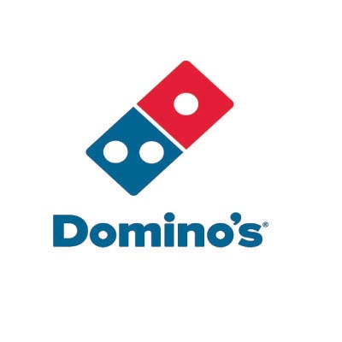[Domino’s Ratings Analysis]

-Mohit Kumar

**[ This Document is reflecting the data that will be used for analysis for the capstone project to be Submitted on Coursera.]**

[Data Requirements]

* Locations of various Dominos outlets for some particular city {New York} [ will be extracted using the foursquare]
* Locations of other competitor's like pizza hut outlets [ will be extracted using the foursquare]
* Ratings and comments by the users on all of those outlets comparative study